

2025 NATIONAL PHOTOGRAPHIC COMPETITION
ENTRY FORM

Entry closing date is 5pm on Friday 27th June 2025

Part 1 – Your details
Entrants Full Name
Branch |  | Membership Number
Entrants Address
Contact Phone number
Email address
Gender of entrant  (Circle applicable) | Male/ Female | Date of Birth

Part 2 – Categories entered
$2 per photo – Maximum $5 per section.
Please enter title of your entry in the spaces below – max of 3 entries per section
Section A: Game Animals
1
2
3
Section B1: Other Wildlife – Birds
1
2
3
Section B2: Other Wildlife – Mammals
1
2
3
Section B3: Other Wildlife – Insects, Reptiles and Amphibians
1
2
3
Section C: Scenic
1
2
3
Section D: Flora
1
2
3
Section E: Human interest
1
2
3

Section F: Best print of all sections (Automatic entry – no extra fee)
Section G: Best Junior Print Automatic entry – no extra fee

Section H: Best photographic Essay on Big Game Hunting
(One entry = six photos)
1
2
3
4
5
6

Section J: Best Game Camera Photo
1
2
3

New Zealand Hunting and Wildlife Cover – Automatic Entry – No extra fee
Supreme Branch Photographic Award – Automatic Entry – No extra fee

Videos – Maximum fee of $20 to enter three videos in up to three categories
Section A: Training/Promotional
Section B: Hunting
Section C: New Zealand Wildlife

Part 3 – Special Competitions 2025
This year we are looking to collect photos to update the NZDA Wilkinson Shooting competition target, and the HUNTS Manual Cover Photo.
Given the special nature of this category, photos taken within the last 3 years (2022-2025) will be considered eligible.
You may enter up to three photos per category, unless stated otherwise.
Ensure that when submitting your photos, file names use the following structure:
'First name Last name - photo name' e.g. 'Jason Smith - Deer in Sunshine'.
Files that do not meet this criteria will not be accepted.
The fees are $2 per photo, with a maximum of $5 per category. Entry fees must be paid for entries to be accepted.

Special Category: Best Hind Photo Competition

This year we are looking to collect photos to update the NZDA Wilkinson Shooting competition target. As such, we require photo's of full body red deer hinds standing broadside, similar to the image below. Due to the special nature of this competition, this category is NOT limited to photos taken in the last 12 months.

It must be at least 12MP and able to be printed to 1300mm high, and 1000mm wide.

1
2
3
Example | 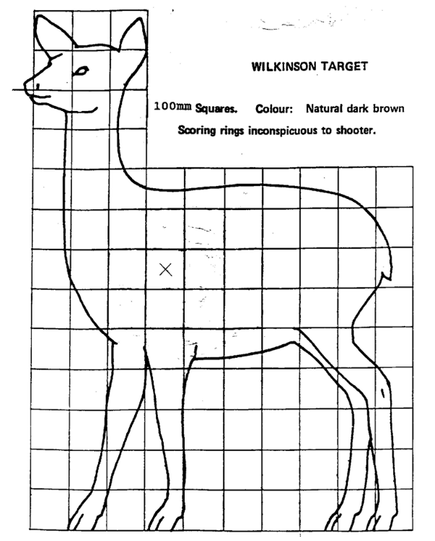

Special Category: HUNTS Manual Cover Photo
This year we are updating our HUNTS Manual Cover photo. As such, the winner of this category will have their photo featured as the NZDA's introduction to hunting and shared with new hunters for the latest edition of our HUNTS Manual.
Photos of individuals in blaze, or demonstrating safe hunting practices will be looked upon more highly, but are not essential.

1
2
3

Part 4 – Your Declaration

The information given above is correct. I agree to be bound by the rules of the competition and I understand that the Judge’s decision is final. I consent to the use of the above information by NZDA, and for it to retain and use this to promote the Association. I acknowledge my right to access and correction of this information. This consent is given in accordance with the Privacy Act 2020.
Signature of entrant |  | Date

Part 5 – Payments
Sections entered | Total cost
Photos $2 per photo (max. $5 per section) | $
Videos Maximum fee of $20 to enter three videos | $
Amount paid to National Office | $

Payment must be made by bank transfer to:
New Zealand Deerstalkers Association Inc
Bank payment details: 03-0558-0139562-000
Particulars: Your name
Code: Your branch name
Reference: Photo Comp

Part 6 – Branch Certification

I certify that (Entrants name) _________________________________________
was a financial member of the _____________________ branch at the time of at the time of taking
the photograph(s) and also at the time of the entry of the photograph(s) into competition.
Date Subscription Paid: ____________________________ (non-centralised branches only)
Name of Branch Officer: ____________________________
Signature of Branch Officer: ________________________ Date _________________
(President / Secretary / Treasurer – please circle one)

Part 7 - Checklist
Please ensure you have a tick for each item below
Checklist |  | Please tick to indicate yes
The following has been entered on the reverse of your photographs (please do not write directly on the back of the photograph – please use a sticky label): | Your full name.
 | Your branch.
 | Category of the competition entered including the section letter and name.
 | Title of the photograph.
I have enclosed the photos to National Office with this form
(Video on memory stick)
I have paid the required fee to National Office (details above)
I have had this entry form certified by a branch officer

