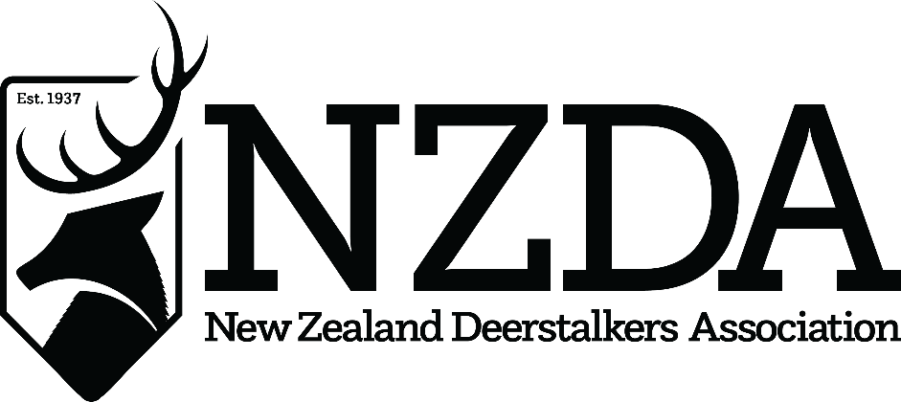

78th National Conference
Hosted by Southland Branch
24th – 26th July 2026

OFFICER NOMINATION FORM
NATIONAL BOARD 2026-27

NZDA Officer Position Nominee is standing for: ________________________________

Name of Nominee: ______________________________________________________
(Mr/Mrs/Ms) (First Names) (Surname)

Nominated by: __________________________________________________________
(Mr/Mrs/Ms) (First Names) (Surname)

Branch: ___________________________ Signed: __________________
(NZ Deerstalkers Association Branch)

Nominees’ Branch executive positions held for more than 12 months:
____________________________________________________________________________________

I QUALIFY FOR ELECTION AS AN NZDA OFFICER UNDER THE NZDA’S
CONSTITUTION AND CONSENT TO MY NOMINATION, AND WISH TO BE
CONSIDERED AS A CANDIDATE FOR THE 2026-2027 NATIONAL BOARD
AT CONFERENCE

Signed: | Date:

This form should reach the National Office and Secretary by no later than 24th June 2026
Email to: <<Insert Name>>@deerstalkers.org.nz

