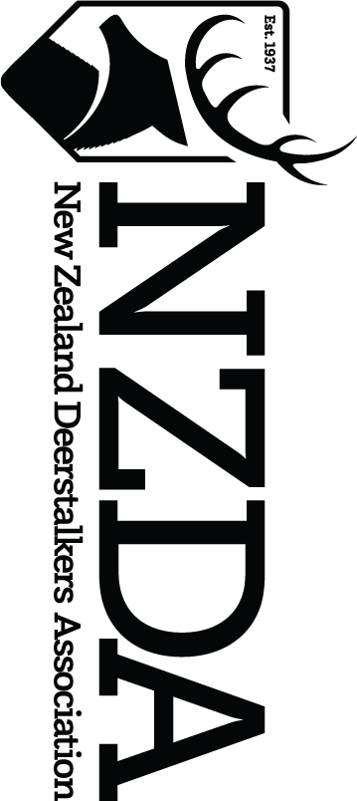

NEWTON MCCONOCHIE AWARD ENTRY FORM 2023

For the Most Outstanding Young Deerstalker of the Year

Entry form must be at the National Office no later than 5pm on Friday 7th July, 2023

Nominating Branch: _______________________________________________________

Nominee Details
Name: __________________________________________________________

Membership Number: __________________________________________________________

Address: __________________________________________________________

__________________________________________

Phone: __________________________________________________________

Email: __________________________________________________________

Date of Birth: __________ / __________ / __________

Date first joined NZDA: __________________________________________________________

__________________________________________________________________________

The above named person is nominated for the Newton McConochie Award for the following reasons: Continue on separate sheet if necessary.

___________________________________________________________________________

___________________________________________________________________________

___________________________________________________________________________

___________________________________________________________________________

___________________________________________________________________________

___________________________________________________________________________

___________________________________________________________________________

___________________________________________________________________________

___________________________________________________________________________

As per the General Rule No. 11: ‘It is the condition of entry that the Association may make use of entries for use in any publicity or for publication in New Zealand Hunting & Wildlife. For any other use the owner’s permission must be sought.’
The competition, paying of fees and posting of this form will be deemed as acceptance of the rules of this competition.
Payment of $5 must be made by bank transfer to:
New Zealand Deerstalkers Association
Particulars: Your name
Code: Your Branch
Reference: YDY Comp
Bank payment details – 03-0558-0139562-000

GUIDELINES TO BRANCHES WHEN CONSIDERING ENTRIES FOR THE YOUNG DEERSTALKER OF THE YEAR AWARD:
Has your nominee:

- Been a member of the branch for at least two years?
- Been involved in hunting trips?
- Been involved in shooting events?
- Been involved in branch working parties?
- Obtained at least one ‘trophy’ of a game species?
- Shown above average hunting or shooting abilities?
- Shown above average initiative at branch meetings and/or hunting trips?
- Demonstrated the ability to work well with others?
The information given above is correct. I agree to be bound by the rules of the competition and I understand that the Judge’s decision is final. I consent to the use of the above information by NZDA, and for it to retain and use this to promote the National Association. I acknowledge my right to access and correction of this information. This contact is given in accordance with the Privacy Act 2020.

Signature of Nominee: __________________________________________________________

Date: __________________________________________________________

BRANCH CERTIFICATION:
We certify that:

1. The information contained in this nomination form is correct to the best of our knowledge.

2. The nominee is a financial member of the ____________________________________ branch.

3. The nomination is a result of a resolution of a properly constituted meeting of our branch or a resolution of the branch committee.

4. Two (2) photographs of the nominee for the Newton McConochie Award, which can be used for publicity purposes, are enclosed with this entry.

Signature of Branch: __________________________________________________________
(President / Secretary / Treasurer – please circle one)

Date: __________________________
Please send this entry form and two photographs of the nominee no later than 5pm on Friday 7th July 2023

