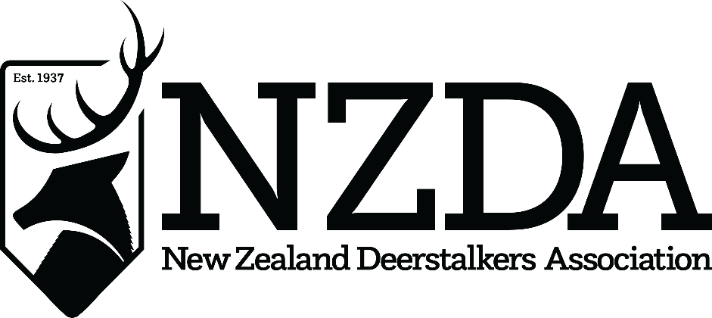

75th National Conference
Hosted by Waikato Branch, Hamilton
21st – 23rd July 2023

OFFICER NOMINATION FORM
NATIONAL EXECUTIVE 2023-24

NZDA Officer Position Nominee is standing for: ________________________________

Name of Nominee: ______________________________________________________
(Mr/Mrs/Ms) (First Names) (Surname)

Nominated by: __________________________________________________________
(Mr/Mrs/Ms) (First Names) (Surname)

Branch: ___________________________ Signed: __________________
(NZ Deerstalkers’ Association Branch)

Nominees’ Branch executive positions held for more than 12 months:
____________________________________________________________________________________

I QUALIFY FOR ELECTION AS AN NZDA OFFICER UNDER THE NZDA’S CONSTITUTION AND CONSENT TO MY NOMINATION, AND WISH TO BE CONSIDERED AS A CANDIDATE FOR THE 2023-24 NATIONAL EXECUTIVE AT CONFERENCE

Signed: ____________________________ Date: ___________________

This form should reach the National Office and Secretary by no later than 21st June 2023
Email to: dan.friedman@deerstalkers.org.nz

