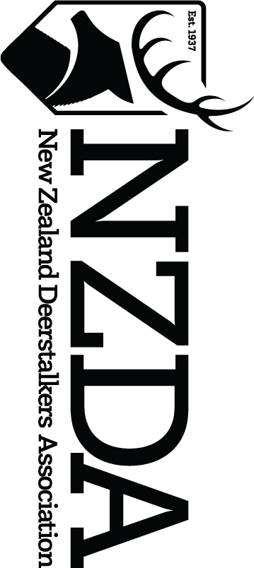

2023 ANTLER, HORN & TUSK (AHT) COMPETITION

ENTRY FORM

Entry form closing date is 5pm Friday 7th July 2023

Entered heads must be at the Conference venue by 5.30pm, Friday 21st July 2023

or Couriered prior (see instructions below)

Part 1 – Your details
Entrant’s Full Name
Branch |  |  | Membership Number
Entrant’s Address
Contact Phone number
Email address
Gender of entrant  (Circle applicable) | Male / Female |  | Date of Birth
Age Category entered (please tick) | Under 18 |  | Aged 18-65 |  | Over 65
Chaz Forsyth Cup (CFC) entry (please tick) | Yes | (If yes, refer to Part 8)
Species Entered |  |  | Date taken
Locality Taken
Brief account of securing the trophy
Please indicate if trophy secured with a bow? | Yes / No

Part 2 – Your Declaration
- In accordance with the rules, this entry was secured without a trophy fee being paid (exception
for Chaz Forsyth Cup entries).
- In accordance with the rules, this entry was secured as per the eligibility for national AHT competitions as listed over the page.
- In accordance with the rules, this entry complies with the wild animal definition.
(See under notes over the page)
I declare the information given above is correct. I agree to be bound by the rules of the competition and I understand that the Judge’s decision is final. I consent to the use of the above information by NZDA, and for it to retain and use this to promote the Association. I acknowledge my right to access and correction of this information. This consent is given in accordance with the Privacy Act 2020.
Signature of entrant |  | Date

Part 3 – Payment
Please note, you only need to make a payment of $30.00 per head entered to cover the entry of each head (it then qualifies for various categories (if eligible)).

Payment must be made by bank transfer to:
New Zealand Deerstalkers Association
Particulars: Your name
Code: Your Branch
Reference: AHT comp
Bank payment details – 03-0558-0139562-000

Part 4 – Branch Certification

I certify that (Entrants name) _________________________________________
was a financial member of the _______________________________________ branch at the time of taking the trophy and also at the time of the entry of the trophy into competition. This entry was taken under Fair Chase as defined in the National AHT Competition Rules and in accordance with the National Association’s Policy and Rules.
Date Subscription Paid: ____________________________ (non-centralised branches only)
Name of Branch Officer: ____________________________
Signature of Branch Officer: ________________________ Date _________________
(President / Secretary / Treasurer – please circle one)
Part 5 – Checklist

Please ensure you have a tick for each item below.
Please tick to indicate yes
I have included a certified Douglas Score sheet with this entry to the National Office
If the entry is a Chaz Forsyth Cup head, I have provided an explanation of my impairment and what fee, if any, was paid.
I have included a photo of the entry to National Office (preferred from when the animal was taken)
There is one form for every entry

I have paid the $30 fee per entry to National Office (details above)

I have included a pre-paid courier ticket with my trophy for returning or made alternative arrangements to collect it
I have labelled my trophy when I sent it (Must arrive before 5.30pm, 21st July 2023) (See notes below on labelling)
I have had this entry form certified by a branch officer
My trophy is in a clean condition

Part 6 – Sending your Trophy and Entry form

Trophy heads will need to be couriered or delivered directly to AHT Douglas Scorers by 5.30pm, Friday 21st July 2023 at Conference:

Address for courier delivery:
Tom Beams
36 Braebrook Drive
Netherby, Ashburton
7700

Your head(s) MUST include:
Affixed owner ID tag – name and phone number
- A branch level Douglas Score sheet
- A photo of your head
- Your return address and contact phone number
- Prepaid courier tickets, if applicable
- If more than one entry, a list of all the heads in the container

Part 7 – Notes

Guide when considering entries for NZDA National Trophy Competition – these are suggested Douglas scores, however this is not a minimum requirement and any trophy can be entered.
Type of trophy | Recommended Douglas Score and above
Fiordland Wapiti | Few entered – so all welcome
Red | 270
Fallow | 180
Rusa | Few entered – so all welcome
Sika | 140
Whitetail | 80
Sambar | Few entered – so all welcome
Tahr | 38
Chamois | 23
Goat | 90
Wild sheep | 60
Drawn pig tusks | 22
Undrawn pig tusks | 18
Note: These suggested scores have been adjusted in 2020 at the recommendation of the judges after changes in the quality and quantity of past entries. Although your trophy may not reach the above score, you may be one of the few entering this year. You have to be in to win!

Part 8 - Rules (a full set of rules are available on NZDA website)
GENERAL ELIGIBILITY FOR NATIONAL ANTLER, HORN AND TUSK COMPETITIONS IN RELATION TO FAIR CHASE:
Entries will not be eligible if A TROPHY FEE HAS BEEN PAID. Entries will also not be eligible for entry if any of the following methods of taking a trophy(s) are used: - The animal:
- Must not have been taken in an enclosed area i.e., behind deer wire or any such fence or fixture that impedes the animal’s unrestricted chance of escape
- Must not have been restrained i.e., in a snare, trap, fence etc
- Must not have been taken with the aid of a spotlight or use of night vision equipment
- Must not have been taken with the help of a rifle mounted thermal imaging or night vision sight
- Must not have been taken from an aircraft, powered vehicle or vessel
- Must not have been coursed by dogs (with the exception of wild pigs).
- Must not have been taken in a manner where animal behaviour has been intentionally influenced by the use of a powered craft
DEFINITION OF WILD GAME ANIMAL: Entries for all categories of Antler Horn and Tusk competitions be accepted from all feral self-sustaining populations of game animals, whether these be from the acknowledged existing feral ranges of the animals or from new or satellite herds which have developed from natural spread, liberations, or escapes. Escapees and animals taken with ear tags or evidence of previous ear tags or other identification markings are not eligible for entry into the Antler Horn and Tusk competition.

ELIGIBILITY FOR CHAZ FORSYTH CUP (CFC):
- All existing rules relating to AHT competitions apply, with the exception that entrants in this class are permitted to pay a guiding/trophy fee.
- Provision of an explanation of the disability/impairment and what guiding/trophy was paid, if any.
- Trophies of any species must be taken under current fair chase and free-range rules, with the exception that a guiding/trophy fee is permitted.
- Heads will be scored and given a Red Deer Douglas Score equivalent. The highest Douglas Score wins. There is no visual judgement.
- Any trophy entered into the CFC competition is not eligible for other AHT competitions.
- Entries in the CFC competition are not eligible for entry into the NZDA Big Game Trophy Records.

