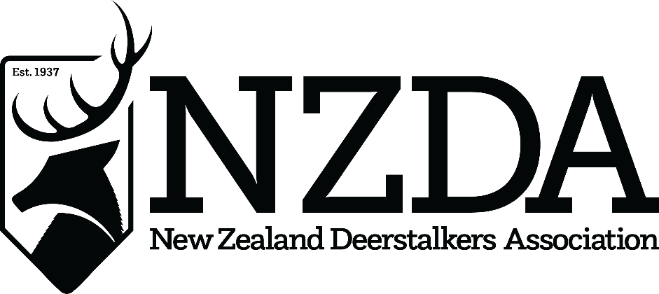

76th National Conference
Hosted by Hutt Valley Branch
12th – 14th July 2024

OFFICER NOMINATION FORM
NATIONAL EXECUTIVE 2024-25

NZDA Officer Position Nominee is standing for: ________________________________

Name of Nominee: ______________________________________________________
(Mr/Mrs/Ms) (First Names) (Surname)

Nominated by: __________________________________________________________
(Mr/Mrs/Ms) (First Names) (Surname)

Branch: ___________________________ Signed: __________________
(NZ Deerstalkers’ Association Branch)

Nominees’ Branch executive positions held for more than 12 months:
____________________________________________________________________________________

I QUALIFY FOR ELECTION AS AN NZDA OFFICER UNDER THE NZDA’S
CONSTITUTION AND CONSENT TO MY NOMINATION, AND WISH TO BE
CONSIDERED AS A CANDIDATE FOR THE 2024-2025 NATIONAL EXECUTIVE
AT CONFERENCE

Signed: | Date:

This form should reach the National Office and Secretary by no later than 12th June 2024
Email to: john.taylor@deerstalkers.org.nz

